

ClinicDB Project Report

Submitted by Name: Shahd Sameh Safwat
ID: 231002256

Supervised by professor:Doctor Mohamed Elsayeh
Teaching Assistant: Habiba mohamed Ibrahim

ClinicDB – Clinic Management System Database

1. Introduction
The ClinicDB project is a relational database system designed to manage the operations of a clinic management environment.
It organizes and stores information about departments, clinics, doctors, patients, and appointments.
The system helps in scheduling appointments efficiently, maintaining patient records, and ensuring that medical operations are well-structured and consistent.

2. Project Objectives
The main objectives of this project are:
- To design a structured database for clinic management
- To manage relationships between doctors, patients, and clinics
- To store and retrieve patient medical history
- To schedule appointments efficiently
- To prevent overlapping appointments for doctors
- To support analytical queries for reporting purposes

3. Database Design (Conceptual Design)
The system consists of the following entities:

3.1 Department
- DepartmentID (Primary Key)
- Name
Each department represents a medical specialization such as Cardiology or Neurology.

3.2 Clinic
- ClinicID (Primary Key)
- Name
- Address
- DepartmentID (Foreign Key)
Each clinic belongs to one department.

3.3 Doctor
- DoctorID (Primary Key)
- Name
- PhoneNumber
- Address
- DepartmentID (Foreign Key)
Each doctor works in one department.

3.4 Patient
- PatientID (Primary Key)
- Name
- PhoneNumber
- Address
- BirthDate
- Job
Patients can book multiple appointments.

3.5 Appointment
- AppointmentID (Primary Key)
- AppointmentDate
- StartTime
- EndTime
- Cost
- Status (scheduled, in progress, postponed)
- Diagnosis
- PatientID (Foreign Key)
- DoctorID (Foreign Key)
Each appointment links a patient with a doctor.

4. Relationships (ER Summary)
- Department → Clinic (1 to many)
- Department → Doctor (1 to many)
- Doctor → Appointment (1 to many)
- Patient → Appointment (1 to many)
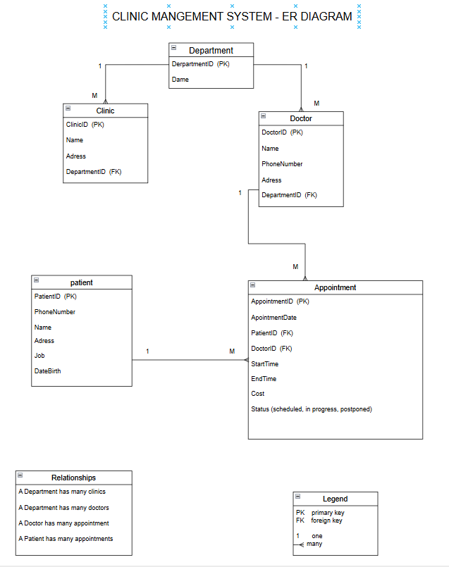

5. Relational Schema
- Department(DepartmentID, Name)
- Clinic(ClinicID, Name, Address, DepartmentID)
- Doctor(DoctorID, Name, PhoneNumber, Address, DepartmentID)
- Patient(PatientID, Name, PhoneNumber, Address, BirthDate, Job)
- Appointment(AppointmentID, AppointmentDate, StartTime, EndTime, Cost, Status, Diagnosis, PatientID, DoctorID)

6. Implementation (SQL Code Summary)
The database was implemented using MySQL and includes:

6.1 Table Creation
All tables were created using CREATE TABLE statements with primary and foreign keys to ensure data integrity.

6.2 Data Insertion
Each table contains at least 10 records for testing purposes, ensuring a realistic simulation of clinic operations.

6.3 Sample Queries
The system supports complex queries such as:

1. Patients diagnosed with fatty liver in the last year
Used to retrieve patient history based on diagnosis and time filtering.

2. List addresses of cardiology clinics
Used to filter clinics based on department type.

3. Total money paid by a patient in the last 3 years
Used for financial analysis per patient.

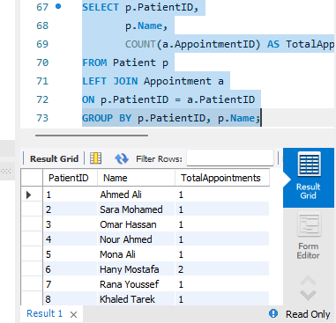
“ This describes a query to fetch each patient and their total appointments.”

7. Trigger (Business Rule Enforcement)
A trigger was implemented to prevent overlapping appointments for the same doctor.
To ensure that a doctor cannot be assigned to more than one appointment at the same time.

Logic:
Before inserting a new appointment, the system checks:
- Same DoctorID
- Same AppointmentDate
- Overlapping StartTime and EndTime
If overlap exists → insertion is blocked.

8. View (Reporting Feature)
A view was created to show:

Doctor_Next_Month
It displays:
- DoctorID
- Total number of appointments in the next month
To help in workload analysis and scheduling distribution.

9. Results and Testing
The system was tested using sample data:
- 10 Departments
- 10 Clinics
- 10 Doctors
- 10 Patients
- 10 Appointments
All queries returned correct results and constraints worked properly.

10. Conclusion
The ClinicDB project successfully implements a relational database for managing clinic operations.
It ensures data integrity through primary and foreign keys, improves scheduling using triggers, and supports reporting using views.
The system is scalable and can be extended in the future by adding:
- Online booking system
- User interface application
- Advanced analytics dashboard

11. Repository and Submission Links
GitHub Repository: https://github.com/ssameh12/ClinicDB_Project
Video Link: https://youtu.be/UgnuQlBvJNg

